HTML AND CSS

HTML and CSS Revision

Objectives
To be able to use an IDE such as Visual Studio Code to edit HTML and CSS.

Reference material
This exercise is based on material from the “HTML and CSS Revision” chapter.

Overview
- In this exercise you will
- Move your work into Visual Studio Code

Estimated duration
The estimated duration for this lab is 20 minutes.

Completed solution
There is a completed solution for this lab.

Step by step instructions
- Obtain a copy of your pre-learning exercise solution. Paste your work into Notepad, and save it.
Note: if you don’t have your solution to the pre-learning available, you can use the sample solution in the
"Chapter 1 - HTML and CSS Revision\Lab Resources" folder
- Note that if you double-click on your saved file, it will open in Notepad, because it has a “.txt” extension.
Rename the file, and change its extension to “.html”. Now, when you double-click on it, it should open in your default web browser, and be displayed correctly. Look at the URL that’s shown in the web browser – it shows where the file is located on your computer.
What this proves is that .html files are simply text files with a different extension. There is nothing special about the contents of the file, and any text editor, including Notepad, can be used to edit the files.
- Next, we are going to open the website in Visual Studio Code. Start the Visual Studio code application.
- Most web sites contain more than one file. Because of this, it is more common to use Code to open the folder containing the website, rather than a single file. Select the File > Open folder menus.
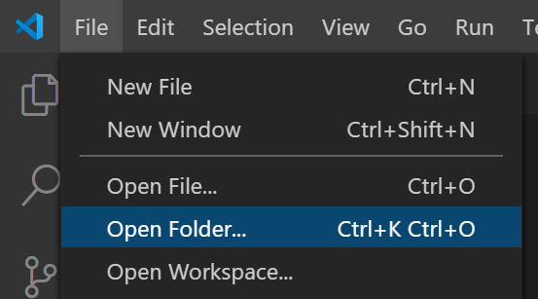
From the Explorer, choose the following folder.
"1 - HTML and CSS including revision\Lab Resources\Chapter 1 - HTML and CSS Revision"
- Double click on the index.html file to view and edit this file.
- Experiment with how Intellisense and auto-completion help you write your code. Start to create a new paragraph by typing "<p>", and notice how, as you type, suggestions are offered. Also, the matching close tag, "</p>", gets added for you automatically.
- Code also supports "Emmet snippets". To enter a snippet, type the snippet code and press the tab key. For an example of this, type "p" then press tab. See that Code automatically turns your single character into the relevant start and end tags.
- Create a new file by clicking the "New File" button 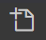 in Explorer, and name it "newpage.html". Edit that page, and type "!" then press tab. This Emmet snippet creates the template for a new HTML page. Once you’ve experimented with how this works, you can delete the newpage.html file – you won’t need it again.
- You can use the keyboard shortcut Ctrl-/ (press the Ctrl key and the Slash key together) to comment or un-comment lines of code. Or, if you select a block of code first, you can comment or un-comment entire blocks of code in one go.
- Another useful shortcut is Shift-Alt-F, which will format your code (for example, fixing any indentation issues). Try this now, by messing up the indentation on some of your code, then pressing Shift-Alt-F.
- In the Explorer section of Code, right-click on your file and select "Rename". Rename your file so that it is called "index.html" – on most websites, if you use your browser to navigate to a folder but don’t specify the exact page, will show the “index.html” page, so it’s always a good idea to use this name for your main page.
- Code is very extensible – there are a huge number of extensions which you can install to add a variety of different features and language-specific support. Let’s install one extension now – an extension which allows us to easily open a web page in a browser.
Click on the 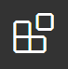 button and then type "open in browser" in the search text box.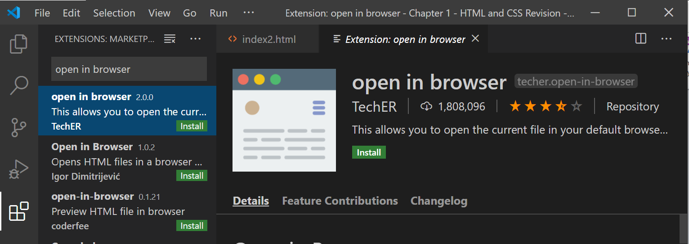
Finally, try out the new extension. There are two ways of using it. With an HTML page displayed, press Alt-B to open it in a web browser. Alternatively, right-click on the file in Explorer, and select "Open in Default Browser".
N.b. if you find the extension does not work correctly, it may be necessary to upgrade to the latest version of Code first. Click the “Settings” gear icon in the bottom-left of the screen, then “Check for updates”.
- Another really useful extension is the Live server extension
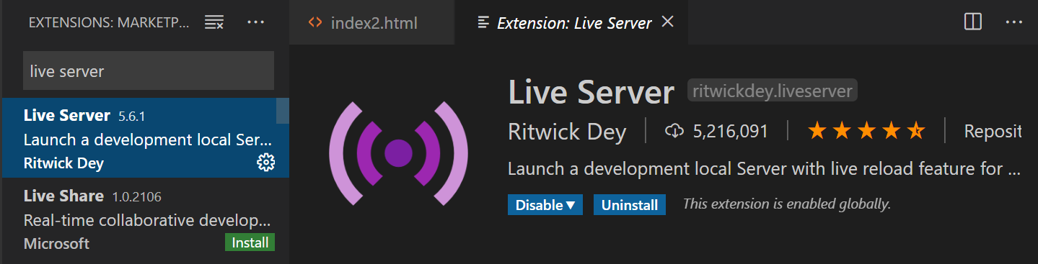
- After installation, whenever you change your code, the browser automatically refreshes.
To run your code with the live server, right mouse click on your HTML page and then select 